Working with Database Applications
Database applications store data in tables made up of rows and columns, similar to worksheets in spreadsheet applications. Just as one workbook in a spreadsheet application may contain many worksheets, one database may contain many tables. In database terminology, rows contain records and columns contain fields.

A record is all the information in a database that pertains to one person, place, or thing. In a survey database, each record contains the data collected from one respondent. A field is one distinct item of information in each of the records. In a survey database, each field contains an answer provided by a respondent to one question.

Database applications have a graphical user interface (GUI). A database GUI is very similar to the GUIs in applications you have probably used more frequently, such as word processing and spreadsheet applications. The interface provides menus that list the actions a user can take. The GUI also provides icons that represent commands on the menus. Icons are grouped together in toolbars.

Database Table Menus
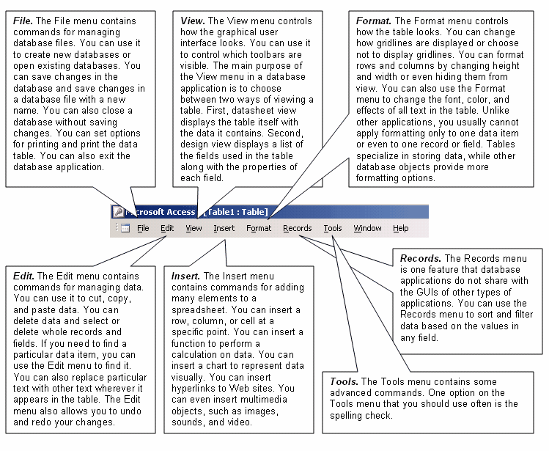

Using the Toolbar
The icons for commonly used options on different menus are gathered together on the Database toolbar. The advantage of the toolbar is that you can select a menu option with one click. You do not have to open a menu first and then select an option.

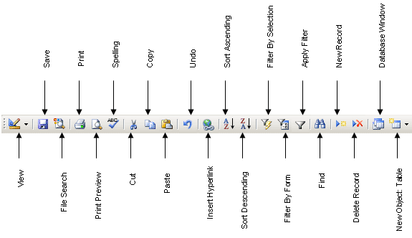

The Database toolbar allows you to start a new database file, open an existing database, and save changes to a database file. You can preview how a database object looks when printed and print the object. You can also cut, copy, and paste data from the toolbar.

